Practical-9
Secure User Registration with Database Insert, Duplicate Email Check, and Password Hashing
Theory
1. Is password_hash() used before storing passwords?
Answer: Yes. PHP password_hash() generates a secure one-way password hash before the user account is inserted into MySQL. The password_hash column stores the hash, not the original password.
2. Is duplicate email/username checked?
Answer: Yes. The registration form checks whether the entered email or username is already registered. It shows an error instead of creating another account with the same value.
3. Are frontend and backend validations consistent?
Answer: The form checks important inputs such as username, email, mobile number and password. PHP also validates the submitted values before saving the account. Invalid mobile number input is rejected.
4. How is user registration protected in MySQL?
Answer: PHP uses MySQLi prepared statements to insert user information. Password hashing, unique email and username constraints, and a CSRF token help protect account registration. A registration audit record is also saved.
Result:
Secure account registration was implemented in StudentHub using PHP and MySQLi. Valid users could register, duplicate email was rejected, password hashes were stored in MySQL, invalid mobile input was blocked, and registration activity was recorded in the audit log.
Evidence of Work (Screenshots)
The following screenshots show the testing and database results of the secure account registration module.

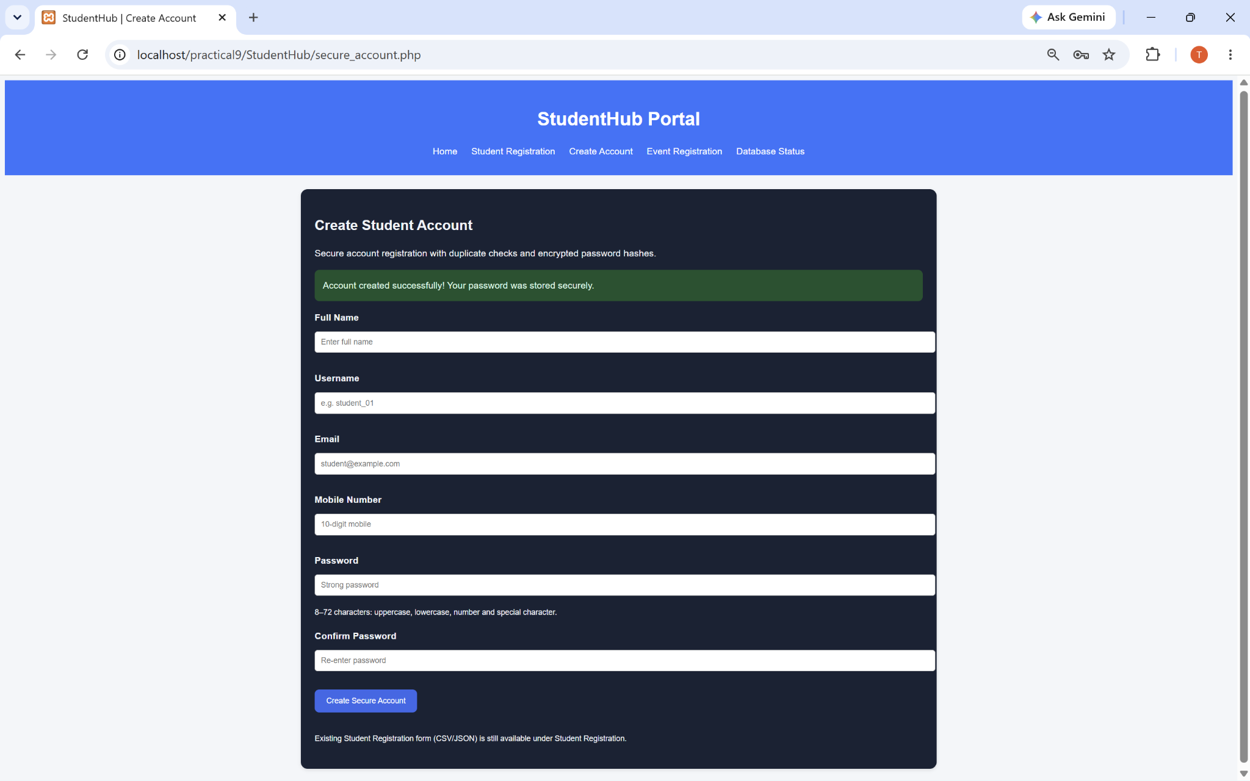
Figure 1: Valid Registration – Account Created Successfully
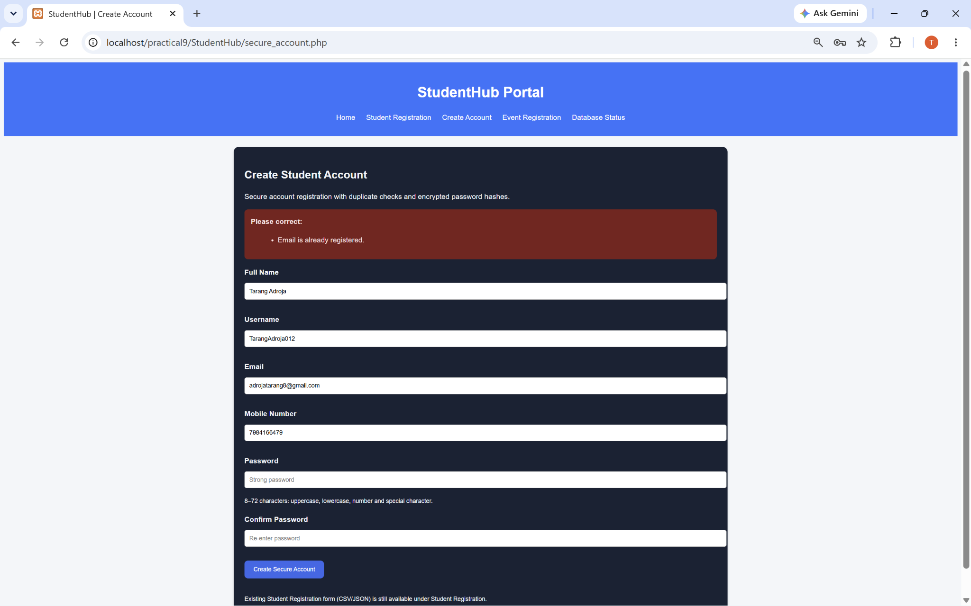
Figure 2: Duplicate Email – Registration Rejected

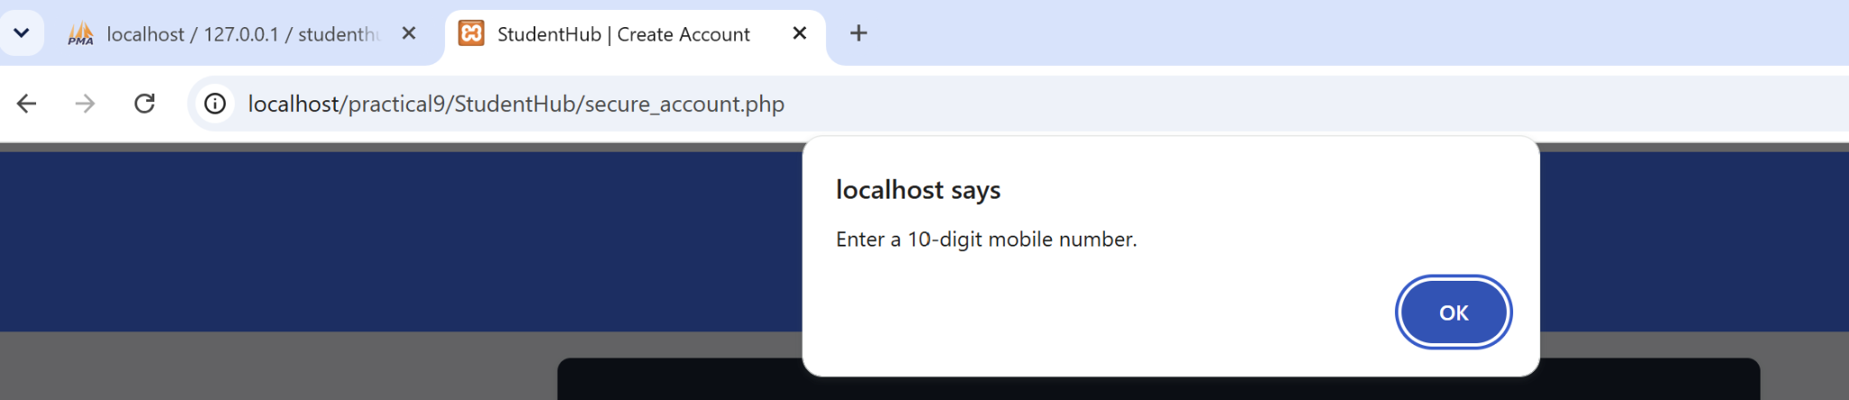
Figure 3: Invalid Mobile Number – Frontend Validation
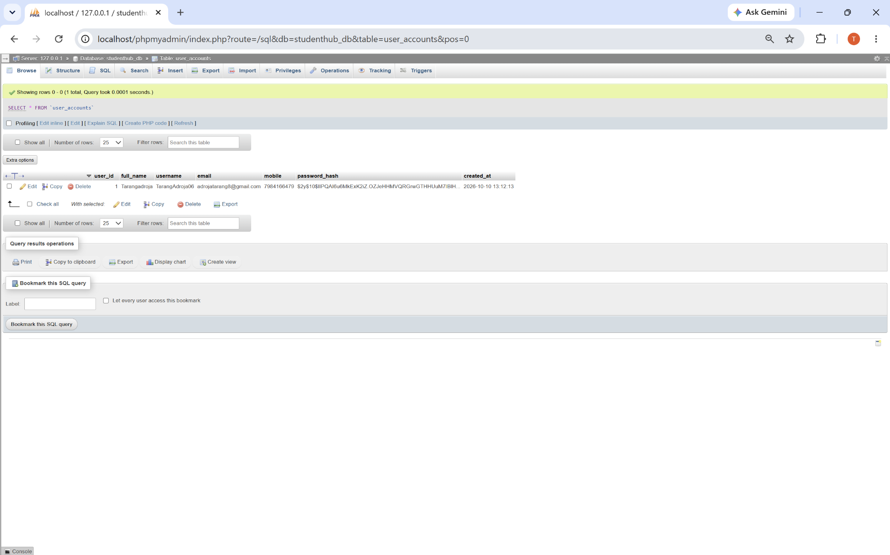
Figure 4: Hashed Password Stored in MySQL user_accounts

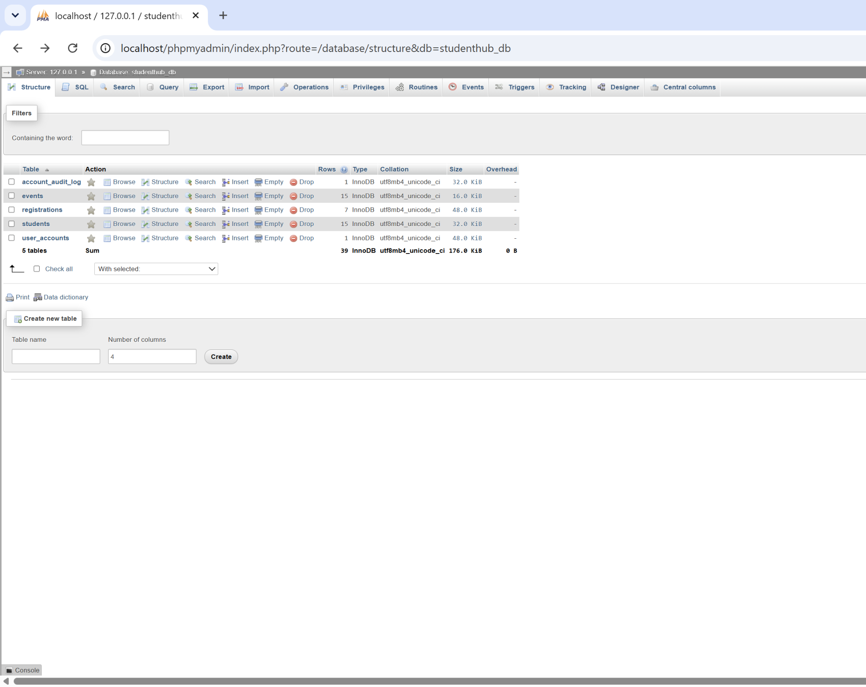
Figure 5: StudentHub Database Structure with Five Tables
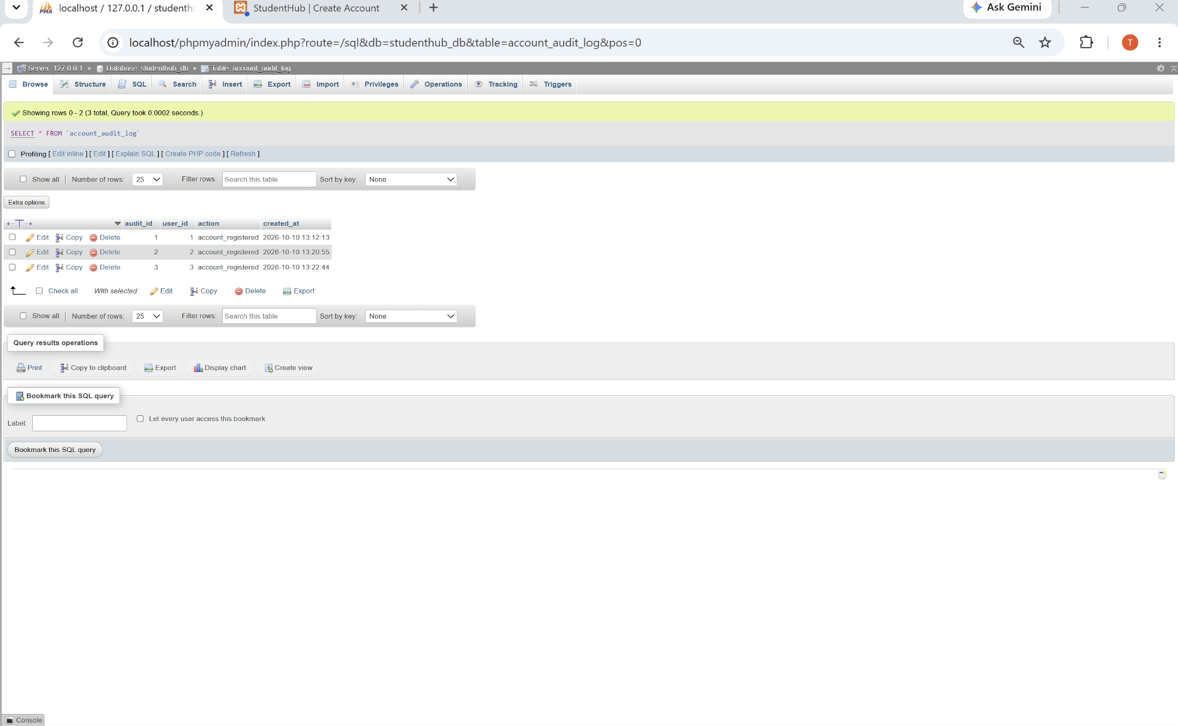
Figure 6: account_audit_log – Registration Activity Records

A. GitHub Repository Link:
https://github.com/adrojatarang8-art/StudentHub
B. Challenges Faced:
• I initially entered an email address into the username field, which caused username validation to fail.
• I had to select studenthub_db before importing secure_accounts.sql to avoid the “No database selected” error.
• Testing duplicate email and username required using both existing and new registration details.
• Understanding password hashing and checking the hash in phpMyAdmin was a new task for me.
• I checked frontend validation and the registration audit log to confirm the security tests.
C. Learning Outcome:-
I learned how to build secure student registration using PHP, MySQLi, and prepared statements.
I understood duplicate email and username checking, frontend/backend validation, and password_hash().
I also learned how to verify hashed passwords and registration audit records in phpMyAdmin.
Faculty Remarks:

